ATR Wording
You completed an Attitude to Risk questionnaire. We felt that this didn’t fully reflect your risk appetite. We agreed that you are a risk rating 5 rather than a 4 as per the questionnaire. You are happy to proceed with a Risk rating of 6.
You confirmed that you wish to increase your Risk rating to 5– Balanced investor, you are aware that this is higher than your agreed risk rating and are happy to take on this risk with your pension. You have confirmed that you are not reliant upon your pension funds and wish for them to have the best growth potential over a 10-year period and feel a balanced approach to this investment would achieve this goal. You are aware that your funds may go up as well as down, and the higher risk you take with your funds, potential there is for larger drops in value.

As a Balanced investor, you do not see yourself as a particularly cautious person and have no strong positive or negative associations with the notion of taking risk. If you have some experience in investments and a degree of understanding of financial matters, then you may be suited to a Balanced approach to investing. You may also be suited to this approach if you make investment decisions reasonably quickly and don’t tend to be particularly anxious about those decisions. As a Balanced investor, you can be inclined to look for a combination of investments with differing levels of risk and understand that you may need to take some risk to meet your investment goals.
It is important to continually review your risk profile moving forward to ensure that this level of risk remains in line with your personal attitudes, and as such I will keep this under review in line with our ongoing review meetings.
Capacity for Loss
XXXX, you are aware that investment values can rise as well as fall, and although your experience is limited to your workplace pension arrangements, you understand that returns are not guaranteed. You confirmed that any potential underperformance would not have a detrimental impact on your day-to-day living. You are in receipt of a full State Pension of approximately £230 per week, continue to work as an HGV driver earning around £300 per week net, and receive an additional £20 per week from your role with the Sea Cadets. Kim contributes a further £1,100 per month from her employment and will also receive a full State Pension of around £230 per week at State Pension age. Your combined income comfortably meets your household expenditure of approximately £1,700 per month, you hold savings of around £6,000, and have no outstanding liabilities. You also hold pension funds totalling approximately £106,000, which form the basis of your retirement provision. We therefore agreed that you have a medium capacity for loss, consistent with your agreed Attitude to Risk level of 5, and appropriate to your current aims and objectives.

Peoples pension current risk - 9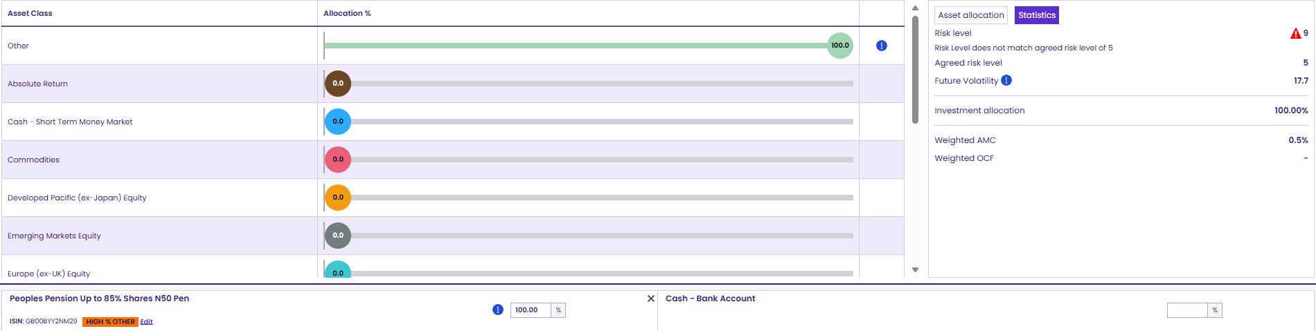
Scottish widows current risk – 4 (funds not on defaqto, built manually)
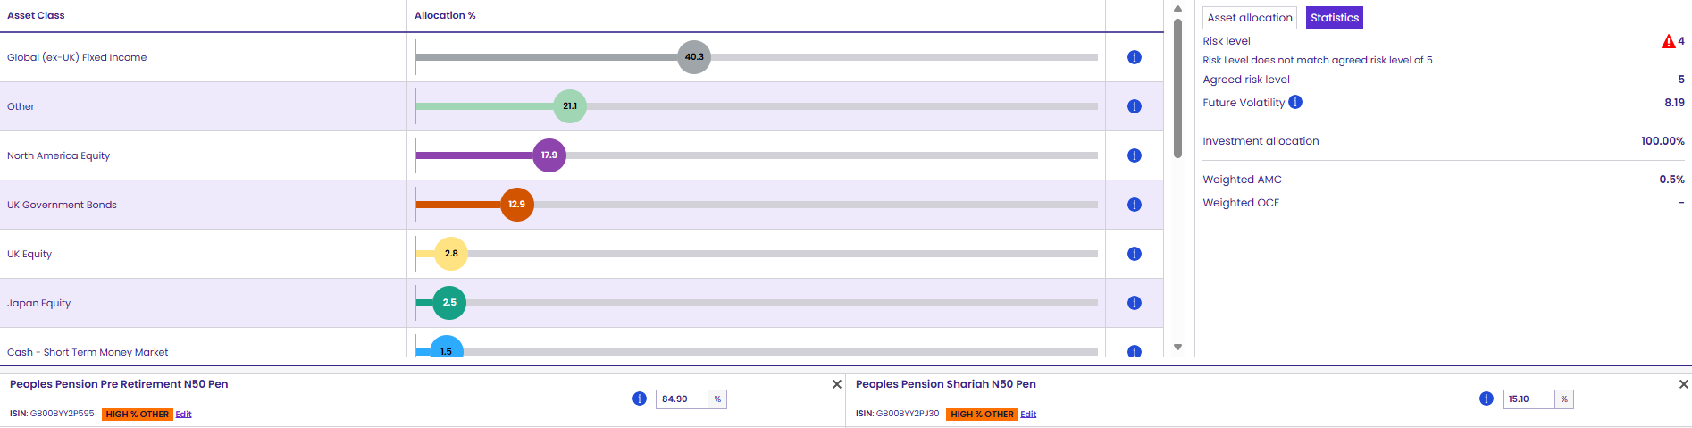
Aviva current risk – 2
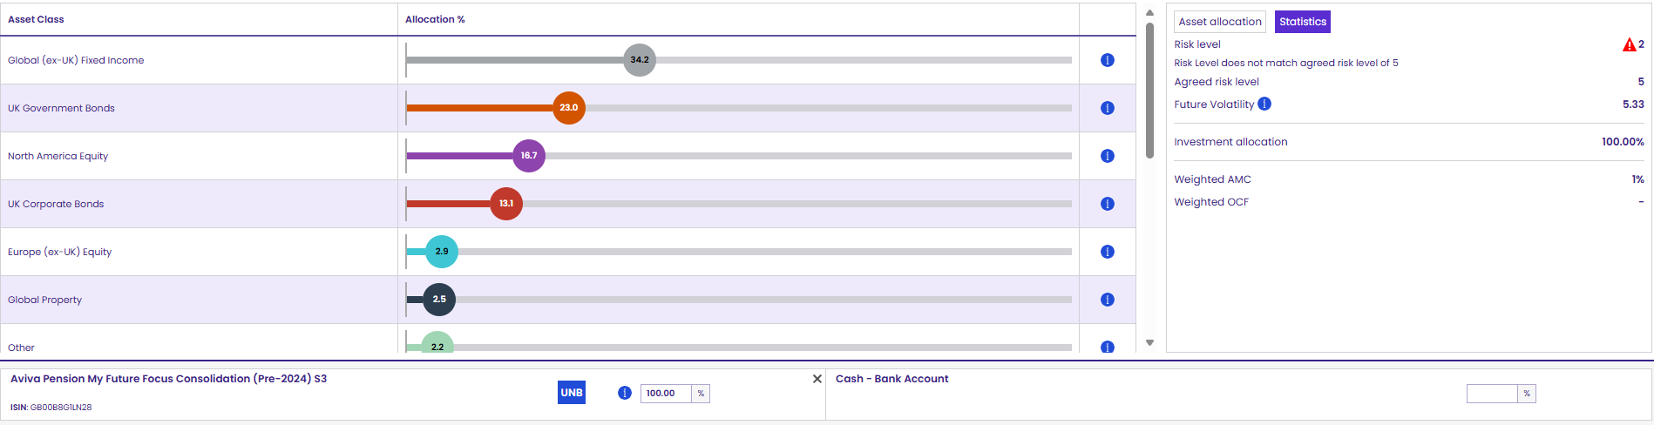
Zurich current risk – 7
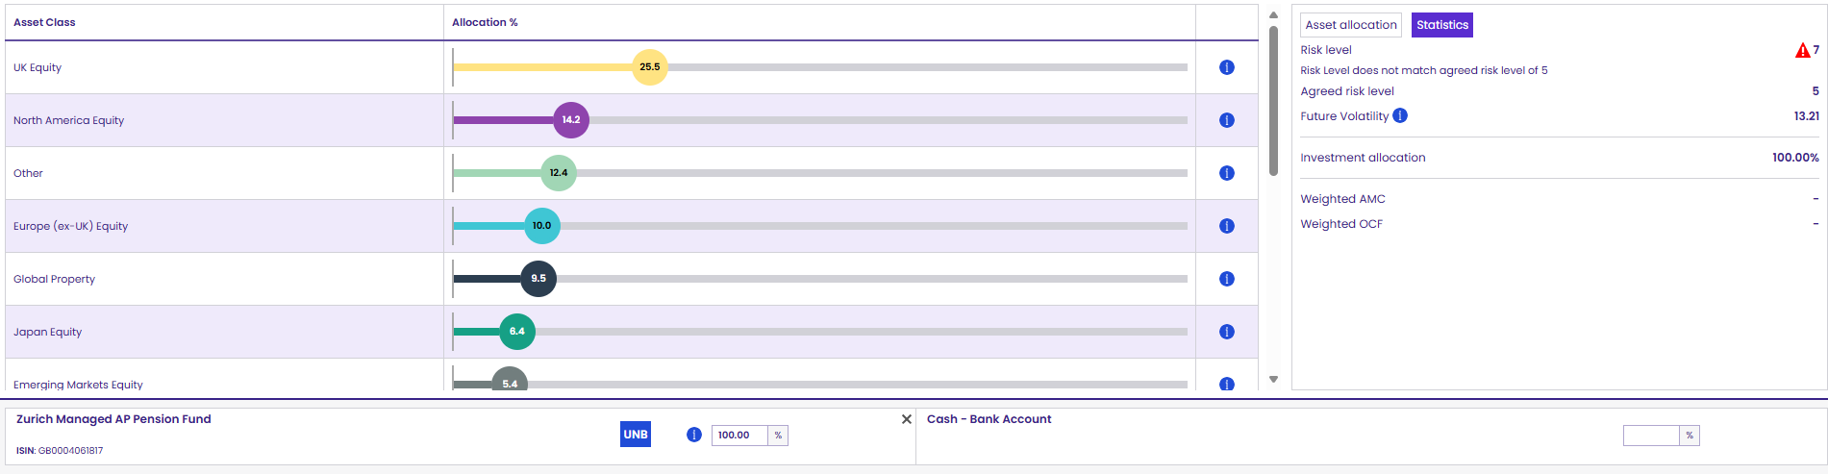

Standard Life current risk – 4
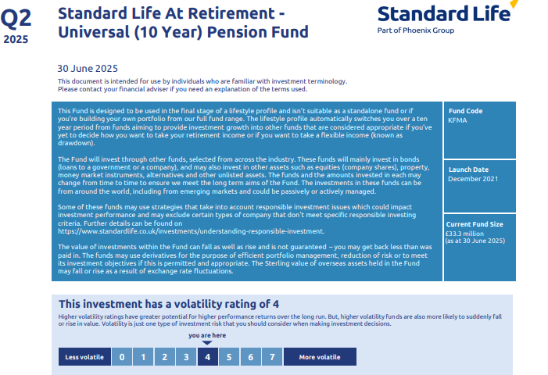
SL performance
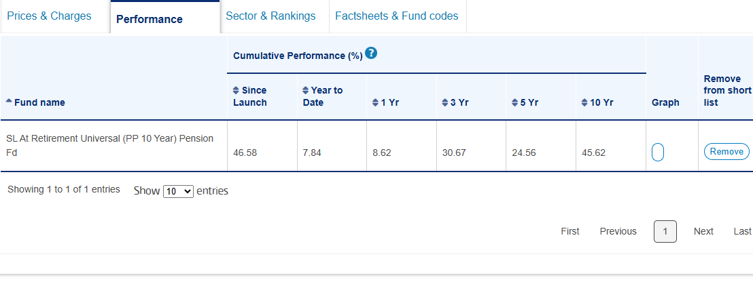

Peoples Penson – alternative option
No alternative as Defaqto risk rates all of them as a 9
Scottish widows – alternative option – 30% liquid fund and 70% of Portfolio three
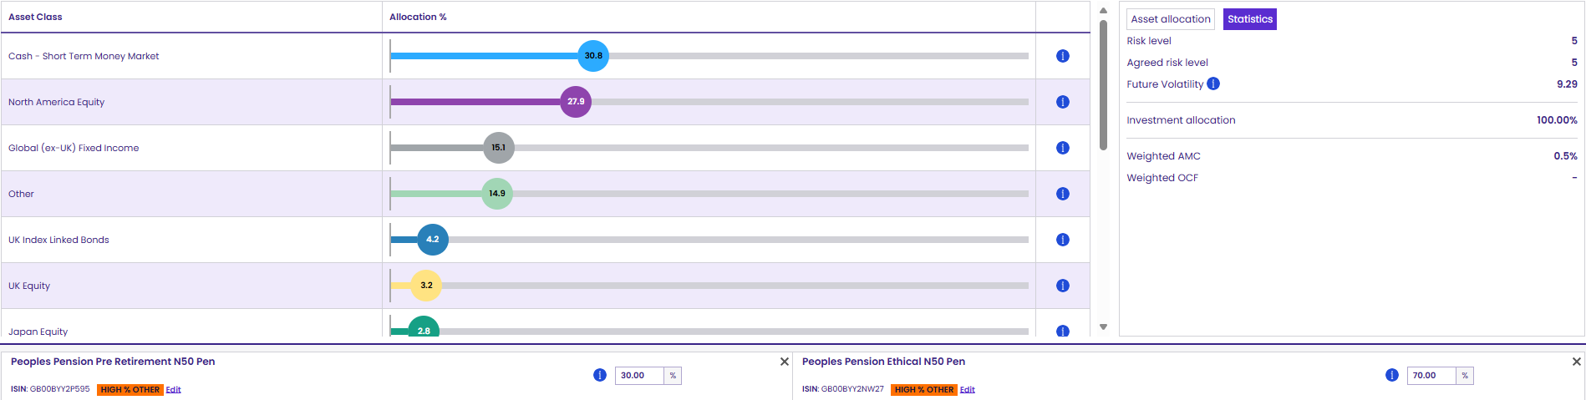
Discounted as no servicing and reduced flexibility with withdrawing, so no more research was done.
Aviva – Alternative option
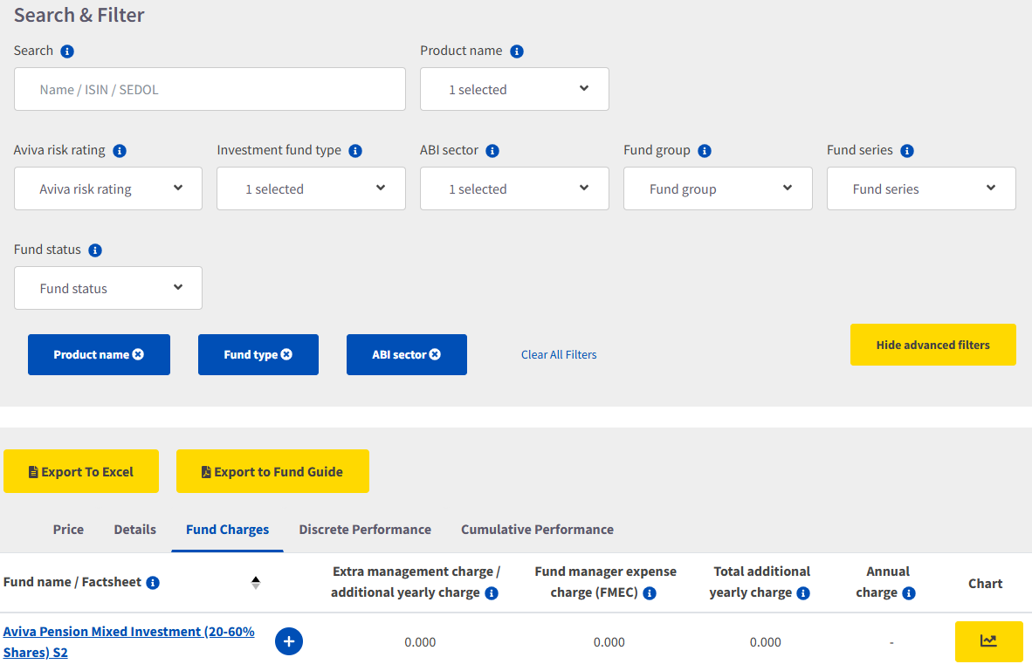
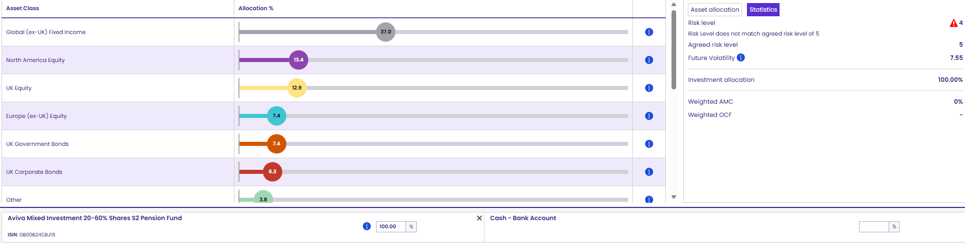
Only mixed asset aviva fund available is risk rated 4 which does not meet the clients ATR.. Discounted switch.

Zurich – Alternative option
Zurich do not have risk level 5 funds, a blend of a 7 and a 2 has been used to create the below 5. They have no multi asset funds in his risk range either, the blend consists of managed AP (client already invested in this and an asset specific fund of Interest deposits. Wouldn’t recommend investing in singular asset types. The blend of funds have not performed as well as what we are offering on Aviva marginally. For these reasons we would not recommend an internal fund switch. The main priority for the client is to consolidate, get a better handle on his pensions and be ready for retirement with all the options.
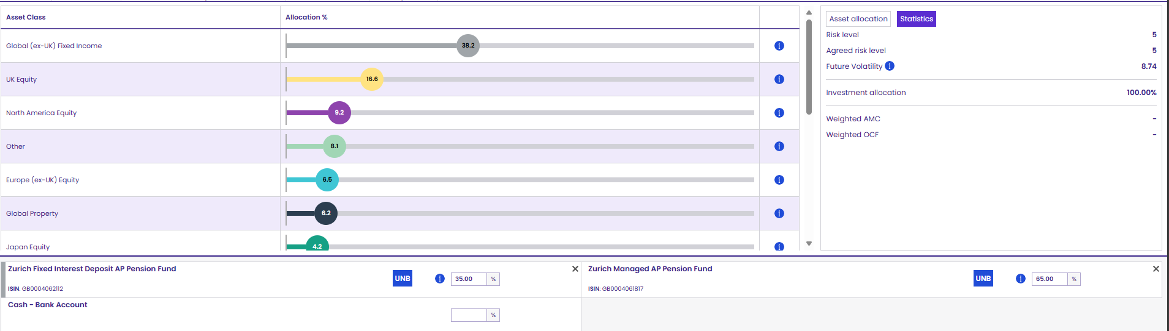
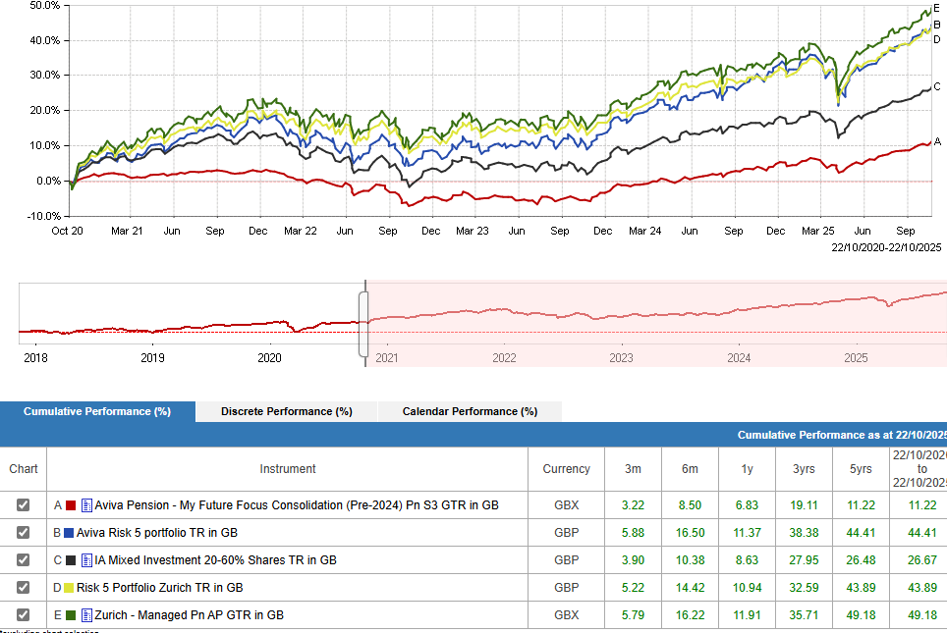

Standard Life – Alternative option
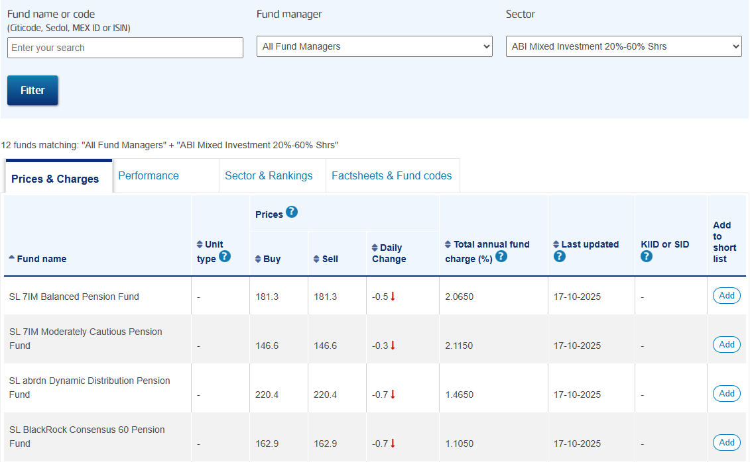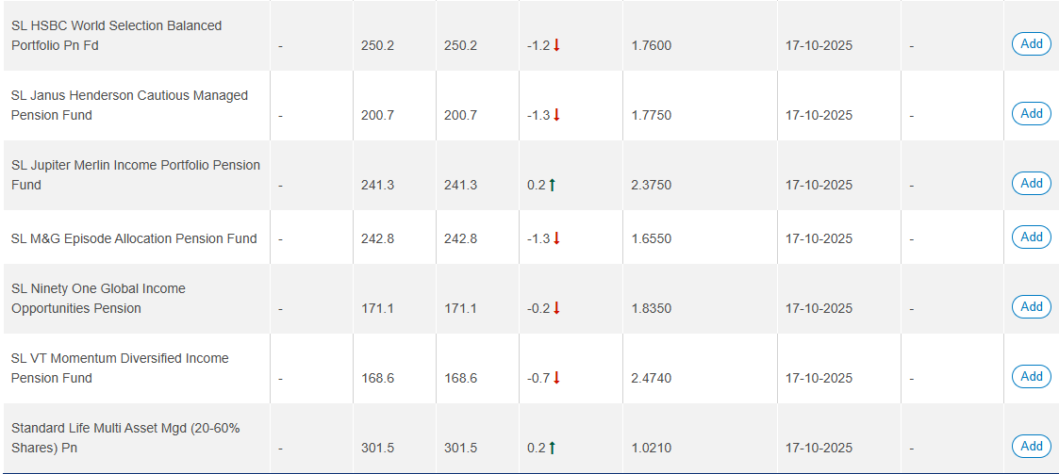
Discounted as all funds within the same range of 20-60% equities are more expensive than what we can offer at Aviva.

SL fund charge
